**Understanding of Hardware and Its Components**

**Section 1: Multiple Choice**

1. Which of the following is NOT a component of the CPU?

Ans: 2.Ram

1. What is the function of RAM in a computer?

Ans: RAM provides temporary storage for data and instructions that the CPU needs to access quickly while performing tasks.

1. Which of the following is a primary storage device?

Ans: 1 and 2 both

Both HDD (Hard Disk Drive) and SSD (Solid State Drive) are primary storage devices.

1. What is the purpose of a GPU?

Ans: A GPU (Graphics Processing Unit) helps your computer display images and videos more quickly and efficiently.

**Section 2: True or False**

1. The motherboard is the main circuit board of a computer  
   where other components are attached.

Ans: True

1. A UPS (Uninterruptible Power Supply) is a hardware  
   device that provides emergency power to a load when the input power  
   source fails.

Ans: False

1. An expansion card is a circuit board that enhances the  
   functionality of a component.

Ans: True

**Section 3: Short Answer**

1. Explain the difference between HDD and SSD.

Ans:

|  |  |
| --- | --- |
| HDD | SSD |
| Hard disk drive | Solid state drive |
| Power Consumption 12 watts | Power Consumption 2 watts |
| HDD have moving parts | SSD have no moving parts |
| Small and light in weight | Large and heavy |
| Random access time 0.1 m/s | Random access time 5.10 m/s |
| Hight reliability | Low reliability |
| Can produce noise from spinning disks | Operates silently |
| Slower access times | Faster read and write speeds |
| less expensive | More expensive |

1. Describe the function of BIOS in a computer system.

Ans:

BIOS stands for **Basic Input/Output System**.

* Initialize and test hardware components.
* Initializes and tests hardware during startup.
* Loads the operating system from storage.
* Configures hardware settings for proper operation.
* Provides a setup interface for system configuration.

The most commonly used types of BIOS are:

1. Legacy BIOS:

* The interface is typically text-based and does not support mouse input.

1. UEFI (Unified Extensible Firmware Interface):

* Modern BIOS that replaces Legacy BIOS, offering advanced features and better performance.
* The interface is graphical and does support mouse input, making navigation more user-friendly.

1. List and briefly explain three input devices commonly used with  
   computers.

Ans:

List of input devices:

* Keyboard
* Mouse
* Scanner
* Microphone
* Webcam
* Touchscreen
* Joystick
* Trackpad
* Digital Pen
* Game Controller

1. Keyboard

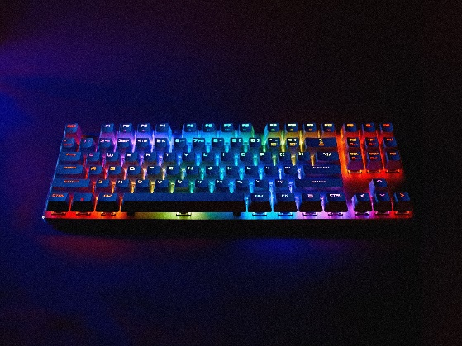

* A keyboard is a device that allows users to enter text, numbers, and special characters into a computer.

1. Mouse

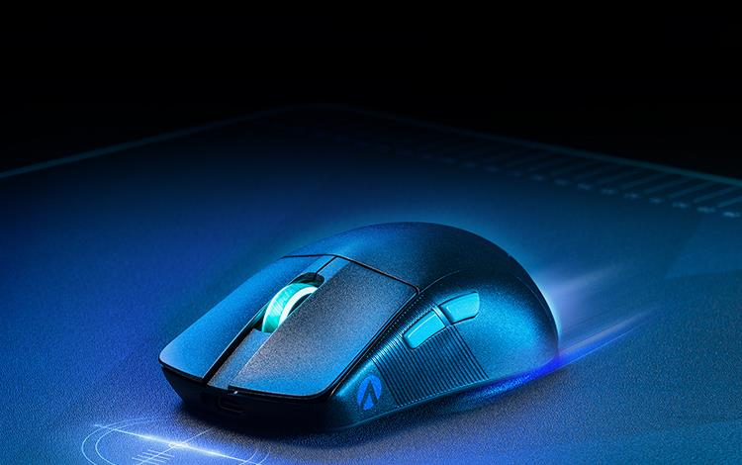

* A mouse is a pointing device that allows users to interact with graphical user interfaces (GUIs) by moving a cursor on the screen.

1. Scanner



* A scanner is an electrical device can read and translate text, images, and other materials into a digital signal. This transforms the documents into a format that computer software programs can use to view and/or edit them. There are many different types of scanners with various resolutions on the market.

**Section 4: Practical Application**

1. Identify and label the following components on a diagram of a  
   motherboard:  
   • CPU  
   • RAM slots  
   • SATA connectors  
   • PCI-E slot

Ans:

**RAM**

**CPU**

**SATA Connector**

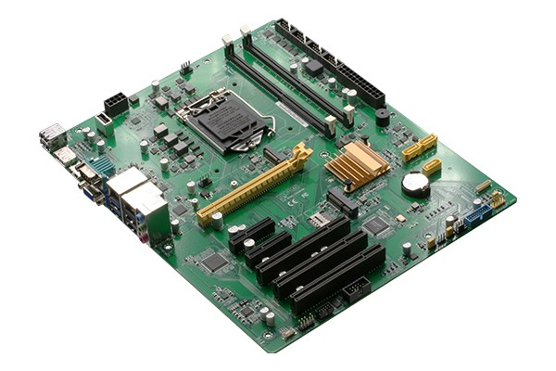

**PCI Slot**

1. Demonstrate how to install a RAM module into a computer.

Ans:

* Power off and unplug the computer.
* Remove the side panel.
* Ground yourself by touching metal.
* Locate the RAM slots on the motherboard.
* Push the clips outward on the RAM slots.
* Align the RAM stick notch with the slot.
* Firmly press the RAM into the slot until it clicks.
* Replace the side panel.
* Plug in and turn on the computer.

Step-1

Buy RAM that is compatible with your computer. It comes in different models, sizes, and speeds.



Step-2

Shut down your computer. Unplug the power cable and all peripherals, like monitors, keyboards, and mice.



Step-3

Open your computer case. Lay the tower on its side to access the motherboard. Use a Phillips-head screwdriver or unscrew the side panel by hand.



Step-4

Find the RAM slots on your motherboard, usually located near the CPU. Most motherboards have 2 or 4 narrow slots, about 4.5 inches long, with tabs on each end. One slot likely already has a RAM stick in it.



Step-5

Remove old RAM (if upgrading)



Step-6

Remove the new RAM from its packaging.



Step-7

Insert the RAM into the RAM slot.

Align the RAM stick's notch with the slot's break. Insert the RAM and press down until the clamps click into place. Ensure matching RAM pairs go into matching slots, which may be labelled or color-coded. Repeat for each RAM stick. While the PC is open, use compressed air to remove dust for better performance.



Step-8

Put the case back on the PC.



Step-9

Power on the computer.



Step-10

Check the RAM in Windows. Press the Windows key + Pause/Break to open the System Properties. Your RAM will be listed in the System section or at the bottom of the window.



**Section 5: Essay**

1. Discuss the importance of proper cooling mechanisms in a computer  
   system. Include examples of cooling methods and their effectiveness.

Ans:

performance and reliability are paramount, the significance of effective cooling mechanisms cannot be overstated. Computers, whether they are used for gaming, professional work, or server operations, generate substantial heat during operation. This heat, if not managed properly, can lead to a cascade of problems that affect both the immediate performance and long-term health of the system.

cooling mechanisms such as air and liquid cooling play pivotal roles. Air cooling, typically achieved through fans and heatsinks, remains the most common method. It works by circulating air over hot components to carry away heat. More advanced systems utilize liquid cooling, where a liquid coolant is circulated through pipes and blocks to absorb heat more effectively than air.

Periodically cleaning dust from fans and heatsinks prevents obstruction of airflow, thereby preserving cooling performance. Additionally, using temperature monitoring software allows users to monitor the temperatures of critical components in real-time, enabling proactive measures to prevent overheating before it causes damage.

1. Explain the concept of bus width and its significance in computer  
   architecture.

Ans:

**Cache**

**CPU**

Front side bus

Backside bus

**South Bridge**

**North Bridge**

**PCIe Controller**

**AGP Controller**

**Memory Controller**

**Onboard Audio**

**ATA Interface(s) Serial ATA Floppy Controller**

**PCI Expansion Bus**

**Onboard USB /Serial/Parallel**

**Onboard LAN**

Bus width, also known as data bus width, refers to the number of parallel data lines that a computer system can transfer data across at once. It plays a significant role in computer architecture and performance. A wider bus width enables faster memory access, larger instruction fetching, higher data throughput, more addressable memory space, and improved power efficiency. However, it also increases power consumption and compatibility issues, which must be carefully managed in system design. In summary, bus width is a fundamental concept in computer architecture that impacts system performance, capacity, and compatibility in various ways.